Member Transfer Form

Please use black ink and write in block capitals. If you require assistance or advice, please telephone the Member and Customer Services Centre on +44 (0)1438 765678 or visit www.theiet.org/contactmembership

Membership Number 83137730

Please can you send the completed form to: The institution of engineering and technology, member and customer services centre, Michael Faraday house, six hills way, Stevenage, Hertfordshire, SG1 2AY, UK or simply visit www.theiet.org/membership/manage/transfer

A: you’re details

Title Mr First Name(s) Philip Peter Andrew

Last Name McGaw Date of Birth 01/10/1983

Home Address 28 Oakcroft Road, Birmingham,.

Postcode B13 0HP

Tel No/Mobile 07969 502 077 Email philip@mcgaw.eu

Employer Name Jaguar Land Rover Ltd. Job Title Automotive EMC and EMF Engineer

Employers Address Jaguar Land Rover, Banbury Road, Gaydon • Warwick •

Postcode CV35 0RR

Please specify the address that you would like correspondence sent to X Home Work

B: DESIGNATORY LETTERS

Please specify which designatory letters you are applying for: TMIET X MIET

Please provide details of science, engineering and technology qualifications that you have completed or are in the process of completing

ONC OND HNC HND Advanced Modern Apprenticeship Level 3 NQF Level 6 (SQCF) Foundation Degree City and Guilds 236 (Electrical installation or similar) City and Guilds Higher Professional Diploma in Engineering CSCS/ECS Gold card MEng BEng MSc BSc PhD BA NVQ 5 NVQ4 CSCS/ECS Platinum Card
Non UK qualifications, please supply a CV X Other, please supply a CV None, please supply a CV Please specify your qualification details in the table below.

For CV Please See attached “Philip McGaw’s CV for IET”
AWARD/COURSE (STATE IF HONS DEGREE) | COURSE TITLE | EDUCATIONAL ESTABLISHMENT OR AWARDING BODY AND COUNTRY | PERIOD OF STUDY FROM/TO
Certificate of Higher Education Please see Figure 1 | Electrical Engineering | University of Plymouth | 2004-2006
 | 17th Edition - Level 3 Certificate in the requirements for Electrical Installations. | City and Guilds | 2010
 | Introduction to ADAS (Advanced Driver Assistance Systems) | Jaguar Land Rover | 2018
 | Automotive SPICE: Introduction | Jaguar Land Rover | 2018
 | Diversity and Inclusion | Jaguar Land Rover | 2018
 | Electromagnetic Compatibility (EMC): Introduction | Jaguar Land Rover | 2018
 | EMC (Electromagnetic Compatibility):Component Process | Jaguar Land Rover | 2018
 | Engineering Basics Training | Jaguar Land Rover | 2018
 | EV (High Voltage Electric Vehicle) Safety Awareness | Jaguar Land Rover | 2018
 | Flat Batteries and Microcontrollers | Jaguar Land Rover | 2018
 | Understanding Selective Catalytic Reduction | Jaguar Land Rover | 2018
 | EV (HeV) Authorised/Senior Authorised Person | Jaguar Land Rover | 2019

C: SUPPORTING INFORMATION
Your supporter can be your employer, a member of the IET or someone that knows you in a work capacity. If you are/have been a student member of the IET you do not need to complete the supporter section below as long as you supply documentary evidence of the qualifications that you have obtained with this form (please submit photocopies as the IET cannot accept responsibility for original documentation).

Title  See Figure 2 |  | First Name(s)
Last Name
Job Title
Membership Number (if applicable)

TMIET MIET FIET CEng IEng EngTech Line Manager Associate University Lecturer

Address
Postcode
Tel No
Mobile
Email

In my opinion this person has achieved the required knowledge and understanding and is a suitable candidate to become a member of the Institution and use the letters TMIET or MIET after their name.

Signature of Supporter Date

D: DECLARATION
I declare that the statements made on this form are to the best of my knowledge true. I confirm that I have not committed any offence of which the Institution of Engineering and Technology (IET) would require me to give notice under its Rules of Conduct. I agree to comply with the Royal Charter and Bye-laws of the Institution and whilst remaining a member I will do my best to promote the interests of the Institution.

I understand and consent to the information provided on this form being processed by the Institution for its sole use and that of its associated organisations for the purposes of promoting, delivering and improving my experience of the Institution, its products and its services, by post and electronic means.
The Rules of Conduct and the Royal Charter and Bye-laws are published on the website www.theiet.org/byelaws

Signature of Applicant Date 18/10/2019



Figure 1 - Certificate of Higher Education
A Certificate of Higher Education is considered to be a Level 4 Higher education qualification.

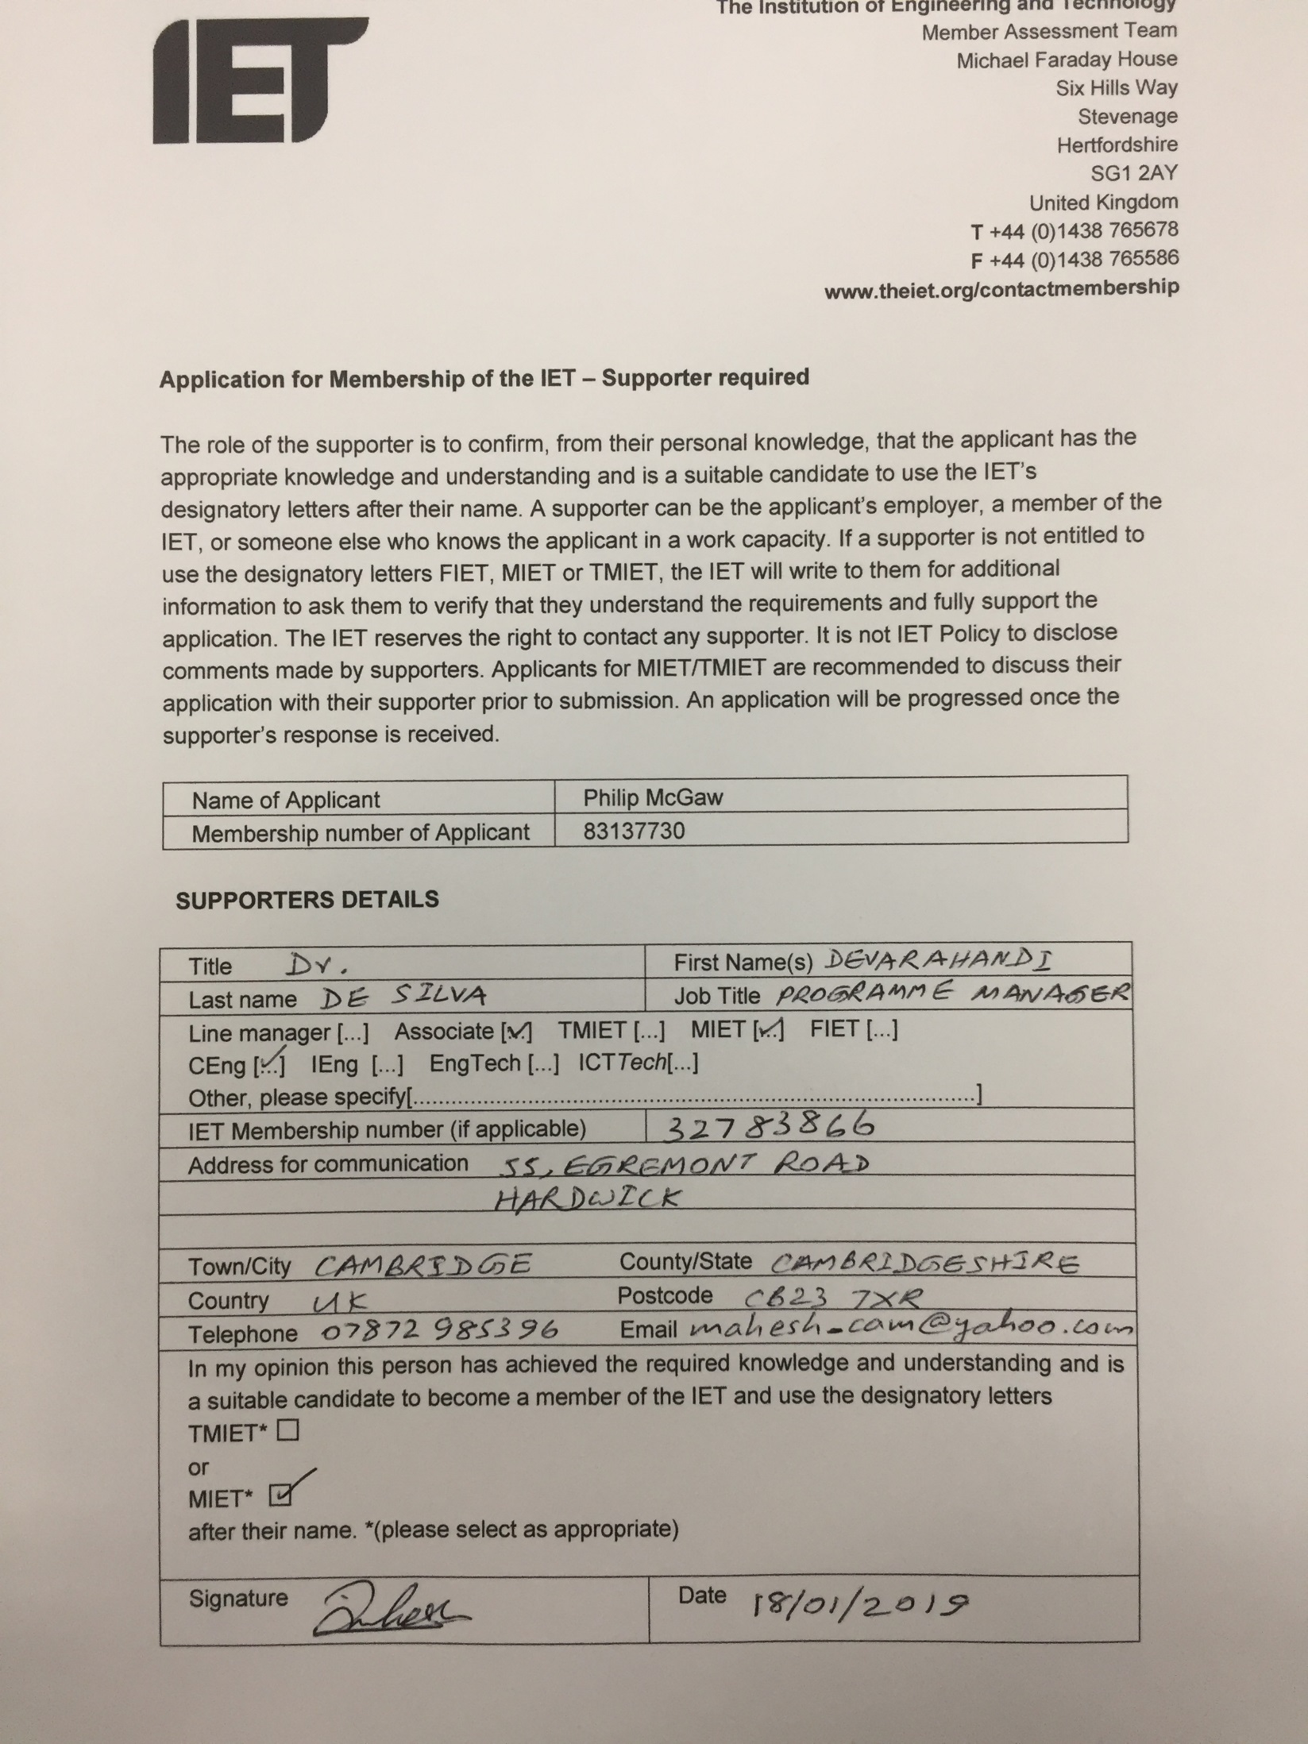
Figure 2 - Supporter's Information

Philip McGaw’s CV for IET

Electro Magnetic Compatibility (EMC) Test Engineer at Jaguar Land Rover UK - Gaydon
September 2018 – Present
I am responsible for EMC and EMF (Electro Magnetic Fields) compliance of vehicle components and sub-assemblies on a number of car lines.
- The EMC Test Engineer Position is a Project Management roll.
- Self-employed contractor (Squashed Fly Ltd.) working in a graduate role within JLR
- Specifying requirements for Components
- Design review of large complex systems and ensuring compliance with requirements.
- Project manage components and sub-assemblies through testing procedures
- Manage internal projects, with cross functional teams in other departments.
- Liaise with internal and external stakeholders regarding the status of their components and component testing
- Liaise with test engineers to confirm the correct procedures are being followed.
- Project manage the setup of a new conducted Emissions and Immunity laboratory.
- Manage EMC Investigations.

EMC Test Engineer at CASS Industries Ltd. - Manchester
March 2014 - September 2018
My main duties involve managing the testing of clients’ electrical and electronic products for compliance with European Directives and appropriate test standards (including EN55032, EN50130-4, and the EN61000 series of standards).
- Working in a graduate role within CASS.
- Management of EMC testing from Quoting to Delivery of Final Report and providing engineering support.
- Production of technical reports, technical plans, procedures and reviews for external stakeholders
- Maintenance of test facility and equipment; including performing calibration
- Improvement of processes and procedures for testing
- Management of network, desktop computers, and servers (Microsoft Office on Windows 7 and 10).

Director at Squashed Fly
September 2006 - Present
- Website design and hosting for a number of clients, including pro-bono work for charities.
- Looking after the day to day running servers and infrastructure (Debian and Ubuntu Linux)
- Investigate and carry out infrastructure changes

IT Consultant
May 2012 - March 2014
- Remote, and On Site Helpdesk Engineer for external clients (including DWP, UK Boarders Agency, Ministry of Justice)
- Working within the Official Secrets Act, and International Traffic in Arms Regulations, Holding Security Vetting,

Technical Clerk and Document Controller at Culham Centre for Fusion Energy - Oxford
March 2010 - September 2011
- Working as part of a group of scientists and engineers on components for ITER and JET.
- Preparation and maintenance of records, quality plans, document reviews and reports.
- Worked on the project for the implementation of Microsoft SharePoint.

Structures Clerk at Network Rail - Swindon
February 2008 - January 2009
- Working within the Western Territory Civil Engineering team.
- Interfacing with and acting as the primary contact between third parties, including Police, members of the public, and the Engineering team.
- Ensuring external stakeholders compliance with ‘The New Roads & Street Act’ and ‘The Road Vehicles Order’.

Year in Industry Student at Scott Wilson Railways - Swindon
June 2006 - August 2007
- Site Surveying for the East London Line, and GSM-R Projects.
- Production of CAD drawings and schematics using Bentley Micro Station and Hevacomp.
- Designing 11 kV, 650 V, 415 V, 230 V power and signalling power distribution circuits,
- Designing of Tunnel and Station Lighting arrangements.
- Production of Technical Reports.

Projects Publications and Consultancy

Production of course material for Introduction to Electronics
A short introduction covering basic electronic and electrical components and first principles; this was delivered as CPD (Continued Personal Development) for CASS Industries, Manchester Makers Ltd. and MadLab.

Production of course material for Introduction to Programing Arduino
A short introduction covering interfacing the Arduino to basic electronic and electrical components, this is a follow on course from the introduction to electronics.

Featured on Hackaday.com
A number of articles I have written have been covered by hackaday.com and other technical sites.

Production of Wi-Fi heart rate indicators
Design and Production of WIFI heart rate indicators for proof of concept for a TV production company

Production of Bluetooth LE UV meter
Design and production of Bluetooth UV meter for use by a marketing company.

Production of Educational Swarm Bot.
I am currently designing a small cheap mobile robotics platform for use with machine learning and computer vision.

https://online.essex.ac.uk/blog/higher-education-qualifications-explained/

